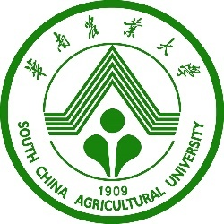 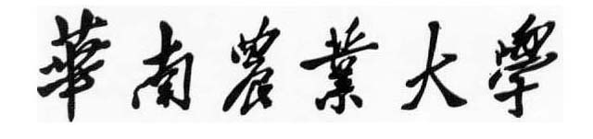

**South China Agricultural University**

**地址：广州市天河区五山路483号 Add:** **NO.483,Wushan, Tianhe , Guangzhou, P. R. China**

**网址：http://www.scau.edu.cn Website: http://www.scau.edu.cn**

**电话：020-85280042 Tel：020-85280042**

**Income certificate**

Date: 01/01/2024

To whom it may concern,

This is to certify that Ms./Mr. Zhangsan is a formal employee of South China Agricultural University. Her/His month/annual income after tax is RMB 12345.78 . Her/His ID number is 123456789101112134.

Signature and Seal: Huichao Yan

Position: Director

Company name: Human Resources Department of SCAU