To apply work permit:
Except the contract, please also provide the following documents:
1. Copy of your Passport/current visa.
2. Fill in the form (Foreign Experts Working Permit Application Record).
3. Copy of Cancellation letter of your previous work permit (if have).
4. Related Working experience certificate (issued by your current/former employer, where you work as an English Teacher, need to stamped, with contact person and contact phone number; need to provide Chinese translation).
5. CV both in English and Chinese.
6. Non-criminal record (with Chinese translation), need to be authentic/notarized by the Chinese embassy.
7. Degree (with Chinese translation), must be authentic/notarized by the Chinese embassy.
8. Health check record (Must go to the place assigned by the government: Health Care Center of Guangdong International Travel, Tel: 87537322 87548300, No. 207. Long Kou Xi Road. Tianhe District, Guangzhou, http://61.144.22.83/Booking/);
You can send me a copy of your current health check record (with Chinese translation), and after arrived in Guangzhou, please go to the assigned place to do it again.
9. e-copy of photo (white background)
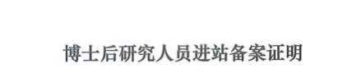

Note： When you get the working permit notice, you can apply working visa (Z visa) to come to China.

Three things you need to do after arrived (Please note: Z visa only valid 30 days from entry date)：

1. Two photos in white background and e-copy plus receipt like below
白底证件照片2张
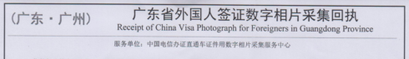

2. Health check
http://61.144.22.83/Booking/
指定体检地址health check place：
广东国际旅行卫生保健中心
Health Care Center of Guangdong International Travel
地址：广州市天河区龙口西路207号
电话：87537322 87548300
No. 207. Long Kou Xi Road. Tianhe District, Guangzhou

3. Register in local police station (like below)
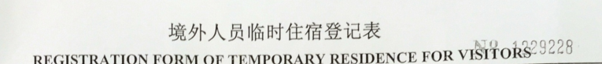

With the three documents above, the international office will help apply work permit and apply changing Z visa to valid residence permit, in order to stay in China legally.

